

**Product recommendation**



By

Sowmya Reddy Baddam

Sri Harika Dungala

Pranay Reddy Nimmala

**ACKNOWLEDGEMENT**

We wish to express our sincere thanks to **Dr. Ahmad Al Shami** **Professor of the Department of Computer Science and Engineering,** for his encouragement and support that he extends towards our project work.



**ACADEMIC HONESTY STATEMENT**

I have read and understand the Southern Arkansas university academic honesty

and plagiarism policy, which states the following

**ACADEMIC HONESTY & PLAGIARISE**

*Southern Arkansas University affirms its commitment to academic integrity and expects all members of the University community to accept shared responsibility for maintaining academic integrity. Students in this course are subject to the provisions of the University’s Academic Integrity Policy, approved by the president and published in the Student Handbook. Penalties for academic misconduct in a course will be an automatic failing grade in the course. Continued enrollment in this course affirms a student’s acceptance of this University policy. Any act of dishonesty in academic work constitutes academic misconduct and is subject to disciplinary action.*

*Acts of dishonesty include, but are not limited to, plagiarism, cheating, or fabrication.*

I understand that cheating, copying, and all forms of plagiarism and academic dishonesty are considered a serious offence in the master’s Program in Computer Science.

I understand that all work I submit is to be my own, done exclusively by me without any outside assistance. I will never submit the work of another student or materials I have found online. If I do collaborate on work or use materials I have found online, it is my responsibility to list any and all outside sources used.

Finally, I understand that the master’s Program in Computer Science at the Southern Arkansas university maintains a set of Rules and Policies which are readily available from the “Current Student” section of the program’s website and that it is my responsibility to be aware of the Rules and Policies and to comply with them as a student in the program

|  |  |  |  |
| --- | --- | --- | --- |
| **Student Name** | **Student ID** | **Date** | **Signature** |
| Sowmya Reddy Baddam | 999900971 | 04/22/2021 | Sowmya |
| Sri Harika Dungala | 999901016 | 04/22/2021 | Sri Harika |
| Pranay Reddy Nimmala | 999901048 | 04/22/2021 | Pranay |

**ABSTRACT**

In this project, We developed four recommendation systems which will help businesses improve their shopper's experience on website and result in better customer acquisition and retention.

Recommendation systems are becoming increasingly important in today’s hectic world. People are always in the lookout for products/services that are best suited for them. Therefore, the recommendation systems are important as they help them make the right choices, without having to expend their cognitive resources.

Due to time constraints and the accepted level of effort exerted on a search, customers may not be able to go through all of the items on the site. As a result, some customers cannot find the exact item they were looking for or an item they truly desire. Consequently, some customers may purchase an item with a high level of cognitive dissonance or not make a purchase at all.

This is where presenting customers with personalized product recommendations can help. Most of the ecommerce organizations earn 35% of their revenue from recommendation.

Below are the tools used for our project.

**Programming Language:** Python.

**Tool:** Jupyter Notebook.

**TABLE OF CONTENTS**

|  |  |  |
| --- | --- | --- |
| **S.No** | **Contents** | **Page No** |
| 1. | Project Introduction | 6 |
| 2. | Understanding The Data And  Pre-Processing | 7 |
| 3. | Recommendation System I | 10 |
| 4. | Recommendation System II | 16 |
| 5. | Recommendation System III | 21 |
| 6. | Recommendation System IV | 25 |
| 7. | Conclusion & Difficulties | 27 |
| 8. | Future Advancements | 28 |
| 9. | References | 29 |

**PROJECT INTRODUCTION**

In our Project we have designed a total of 4 recommendations systems based on business context

**Recommendation system part I:** When a business is setting up its e-commerce website for the first time without any product rating. For a business without any user-item purchase history, a search engine based recommendation system can be designed for users. The product recommendations can be based on textual clustering analysis given in product description.

**Recommendation system part II:** Recommendation System using Cosine similarity by implementing the K-Nearest Neighbours algorithm. I will also predict the rating of the given movie based on its neighbours and compare it with the actual rating.

**Recommendation system part III:**

1. Based on product rating we would find out the most popular product and recommend them to new customers.
2. Once we have the user purchase history. We can recommend user preferred products, by comparing the user with other similar users based on the products purchase history and their rating for the product and then recommend them with K-Nearest Neighbours algorithm.

**Recommendation system part IV:** Model-based collaborative filtering system based on customer's purchase history and ratings provided by other users who bought items similar items.

**UNDERSTANDING THE DATA AND PRE-PROCESSING**

**1. Import dataset in pandas:**

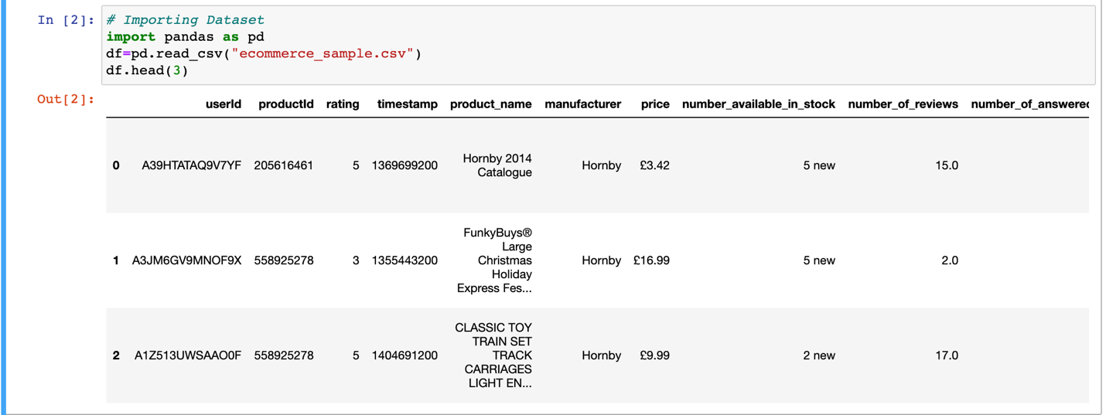

## 2. Extracting numbers from strings

The **number_available_in_stock**column in the dataset is a text field that has the number of new stock within the string hence we are extracting just the number.

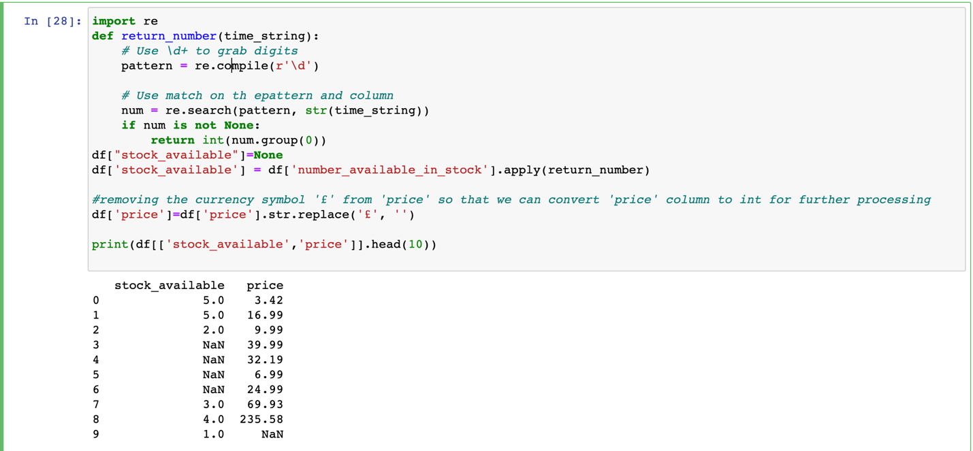

## 3. Checking column types & Converting Column types

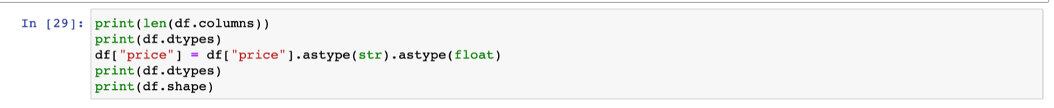

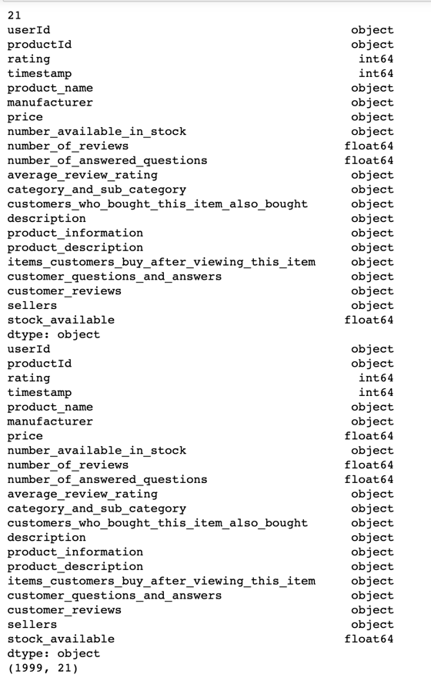

## 4. Dropping missing data and removing irrelevant columns Let's remove some of the rows where certain columns have missing values.

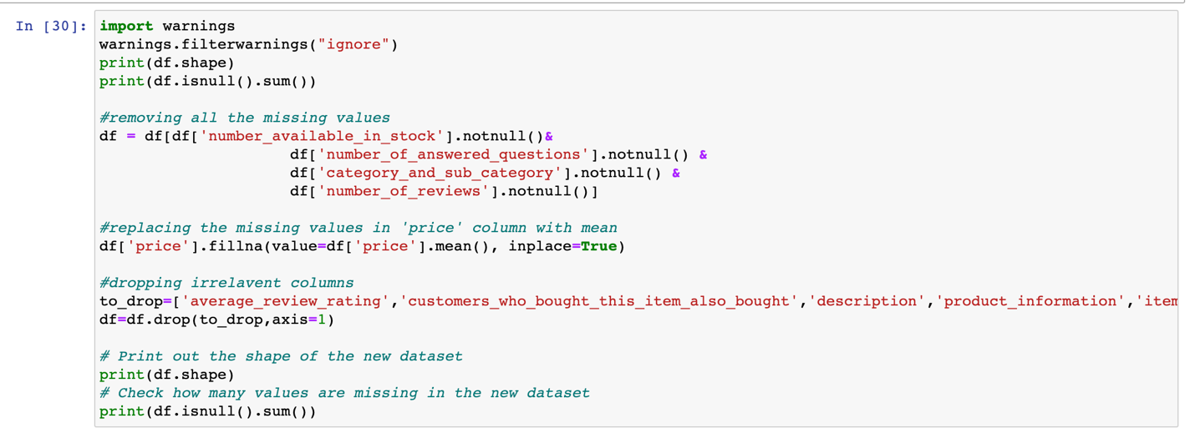

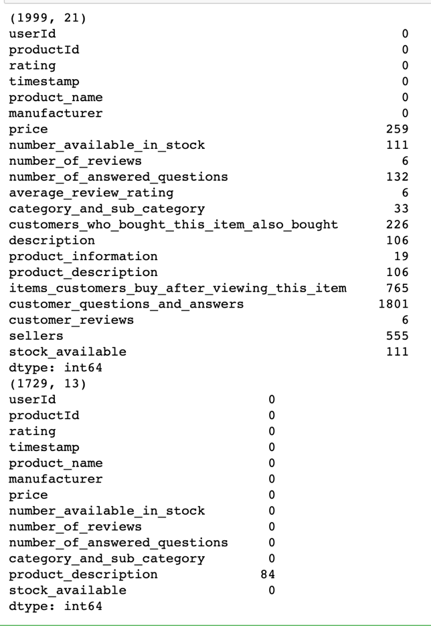

## 5. Encoding categorical variables

## Manufacturer column has 5 unique categories, hence with the help of one-hot encoding we are converting them to numerical for further processing.

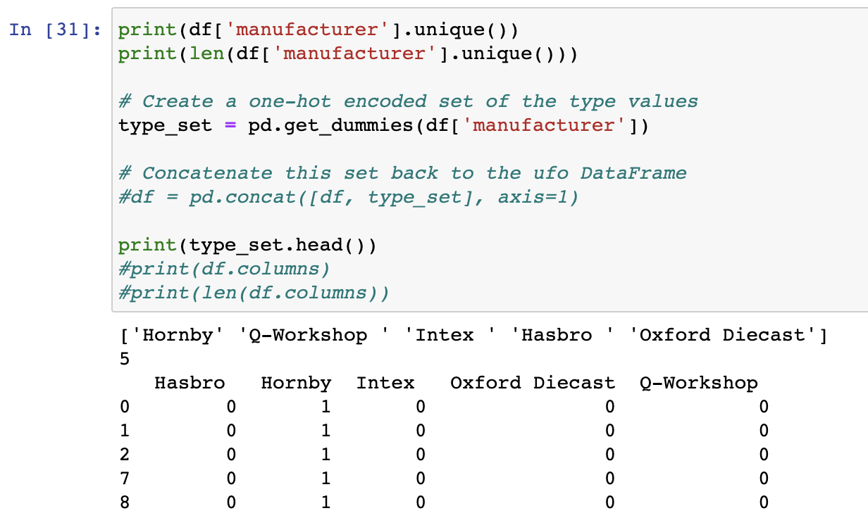

**RECOMMENDATION SYSTEM I**

When a business is setting up its e-commerce website for the first time without any product rating. For a business without any user-item purchase history, a search engine based recommendation system can be designed for users. The product recommendations can be based on textual clustering analysis given in product details(Name, Description, Category). Predictions done based on other products from the same cluster on key search words.

**STEP 1:** Taking relevant columns for analysis

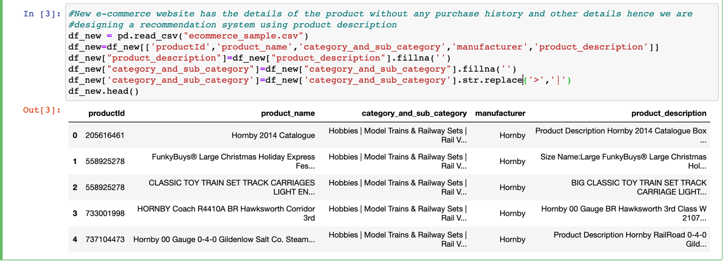

**STEP 2:**

**Text vectorization**:

Machine learning algorithms operate on a numeric feature space, expecting input as a two-dimensional array where rows are instances and columns are features. In order to perform machine learning on text, we need to transform our documents into vector representations such that we can apply numeric machine learning. This process is called feature extraction or more simply, vectorization, and is an essential first step toward language-aware analysis.

With the help of Text vectorization we are converting the text in product description, Manufacturer and Category into numerical data for analysis.

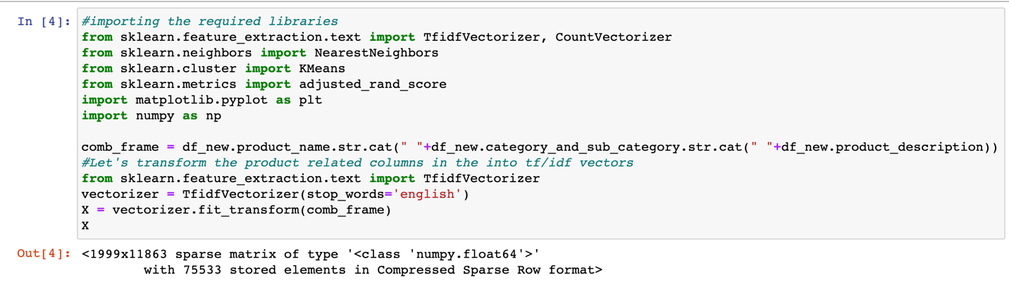

**STEP 3:**

**K-Means:**

A fundamental step for any unsupervised algorithm is to determine the optimal number of clusters into which the data may be clustered. The Elbow Method is one of the most popular methods to determine this optimal value of k. We now demonstrate the given method using the K-Means clustering technique using the Sklearn library of python.

In cluster analysis, the elbow method is a heuristic used in determining the number of clusters in a data set. The method consists of plotting the explained variation as a function of the number of clusters, and picking the elbow of the curve as the number of clusters to use.

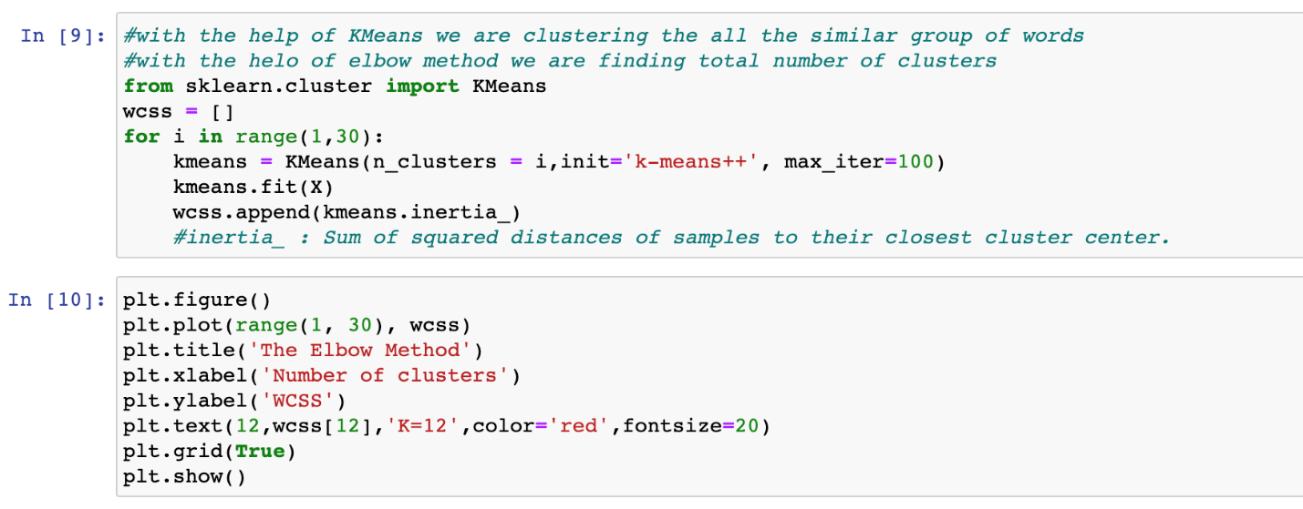

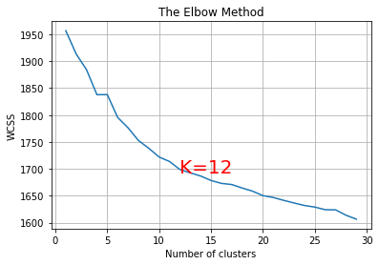

To determine the optimal number of clusters, we have to select the value of k at the “elbow” ie the point after which the distortion/inertia start decreasing in a linear fashion.

From the above visualization, we can see that the optimal number of clusters should be around 12.

**STEP 4:**

Fitting K-Means to the dataset

Now that the k-means class is ready, the next step is to fit it to the data in scaled_features.

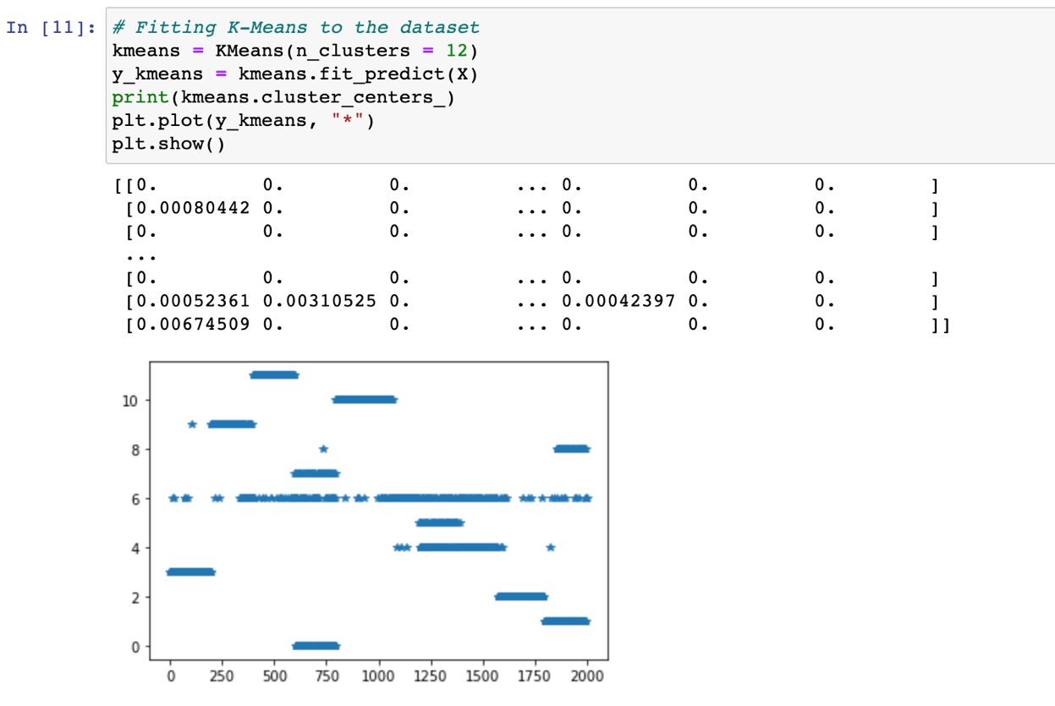

**Printing top 10 words in each cluster:**

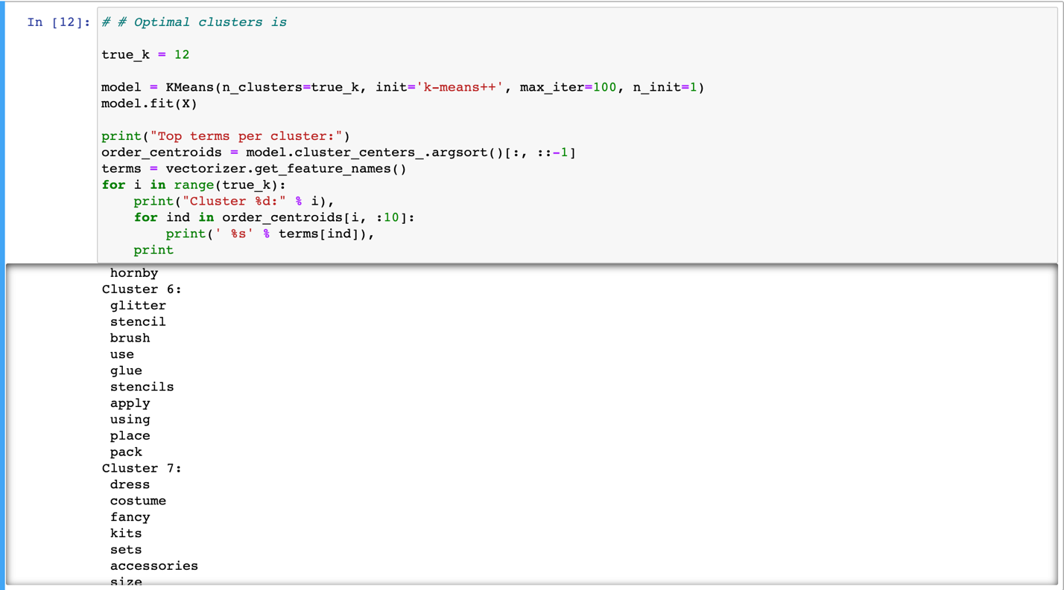

For instance take a look at the below example, If user searches the word ‘dress’ in search bar than we are recommending them with product names that are related to the word ‘dress’. Since it belongs to cluster 7 the recommendation system will suggest the products that are in cluster 7.

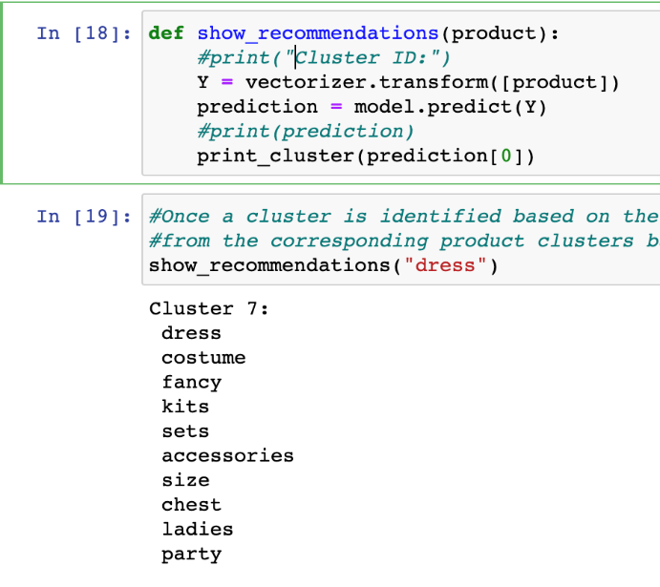

**STEP 5:**

Once a cluster is identified based on the user's search words, the recommendation system can display items from the corresponding product clusters based on the product details (name, category and description).

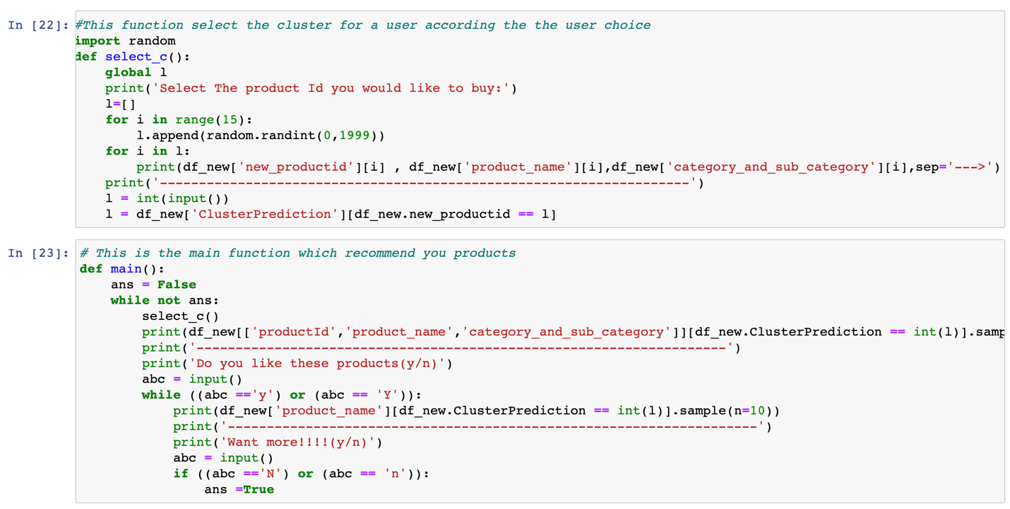

First we randomly show 10 products to the user, based on the product selected by the user, we are recommending the user with similar products. We have categorised the clusters based on product name, category and description. Once the user selects a product, our recommendation system would recommend products which are in a cluster.

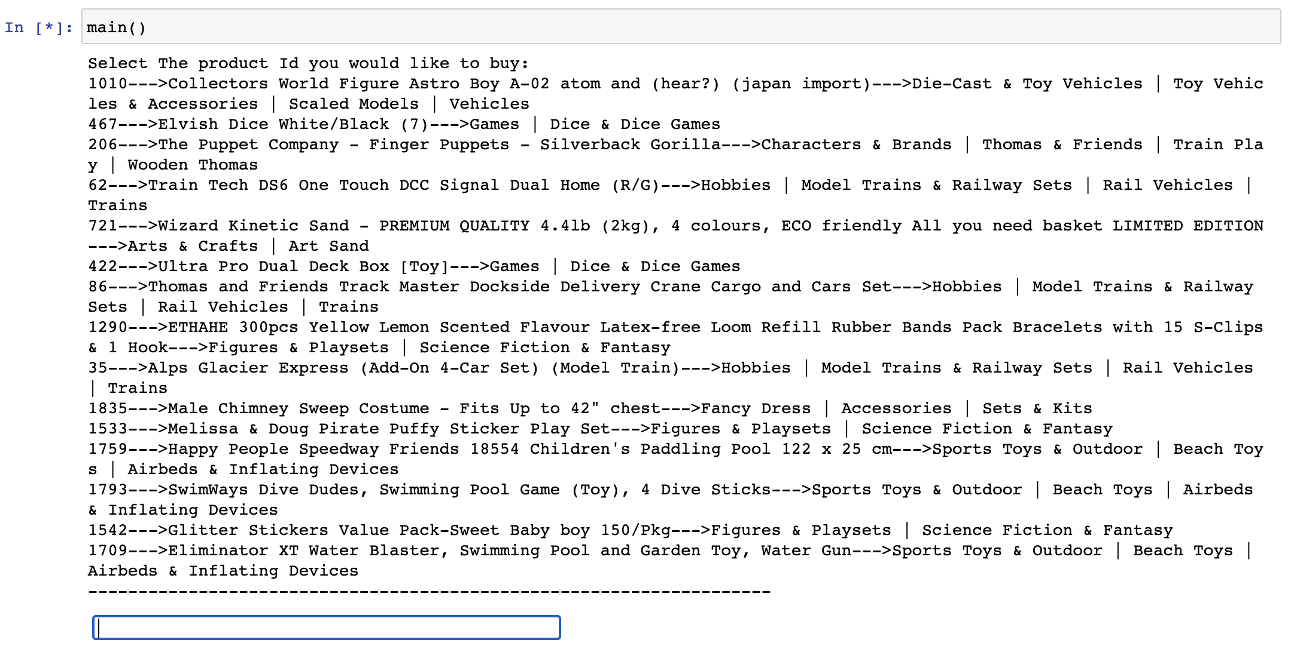

For instance, if the users select the product ‘1010’ as that product belong to the category “Die-Cast & Toy Vehicles” as the related products are displayed below.

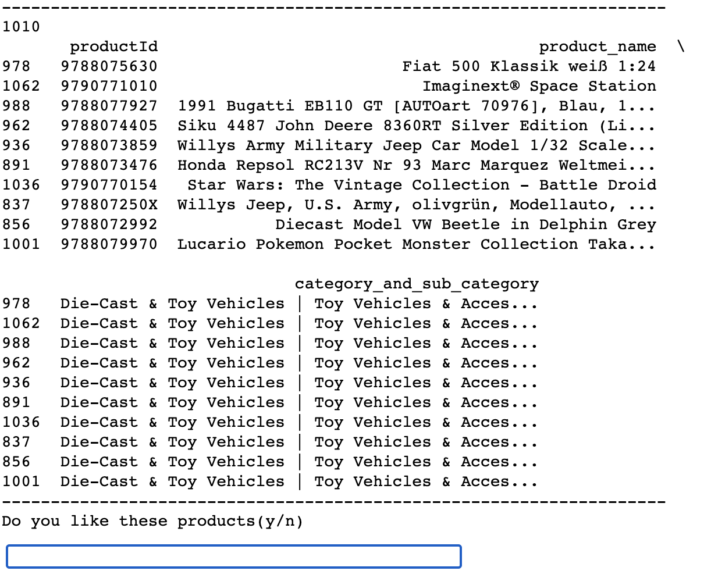

Final, we are asking the user if he/she likes the suggested products, if so then we would suggest more or else we would stop suggesting.

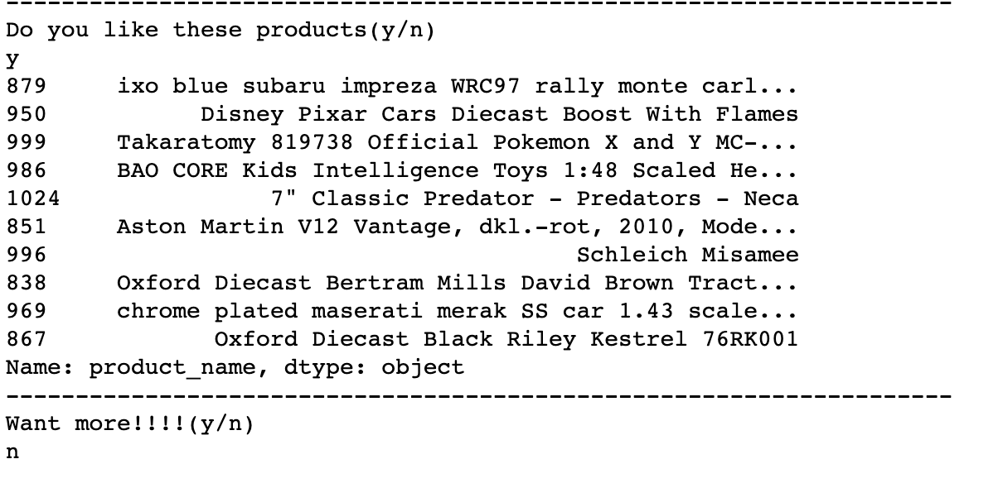

**Summary:**

This works best if a business is setting up its e-commerce website for the first time and does not have user-item purchase/rating history to start with initially. This recommendation system will help the users get a good recommendation to start with and once the buyers have a purchased history, the recommendation engine can use the model based collaborative filtering technique.

**RECOMMENDATION SYSTEM II**

Recommendation System by implementing the K-Nearest Neighbors algorithm. I will also predict the rating of the given movie based on its neighbors and compare it with the actual rating. Based on product category and manufacturer, we are finding the similarity between the products and recommending them to the users. We are finding the similarity by finding the distance between the products.

**Working with the Category Column**

Science Fiction & Fantasy appears to be the most popular Category followed by Figures & Playsets

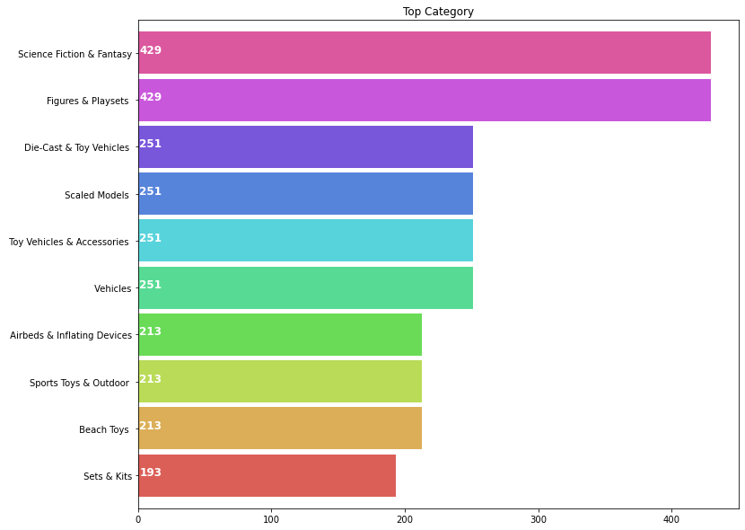

Now lets generate a list 'CategoryList' with all possible unique genres mentioned in the dataset.

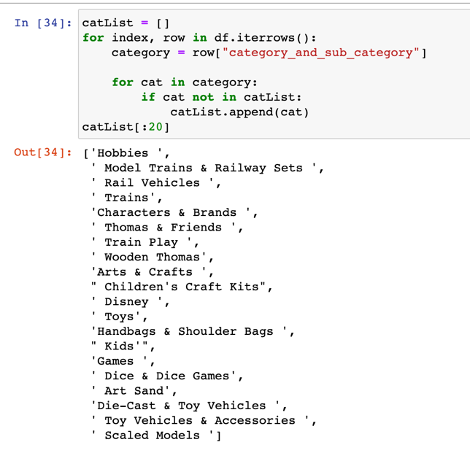

**One Hot encoding**

A one hot encoding allows the representation of categorical data to be more expressive. Many machine learning algorithms cannot work with categorical data directly. The categories must be converted into numbers. This is required for both input and output variables that are categorical

One Hot Encoding for multiple labels. In order to find the distance between the products, we are converted these columns to numerical.

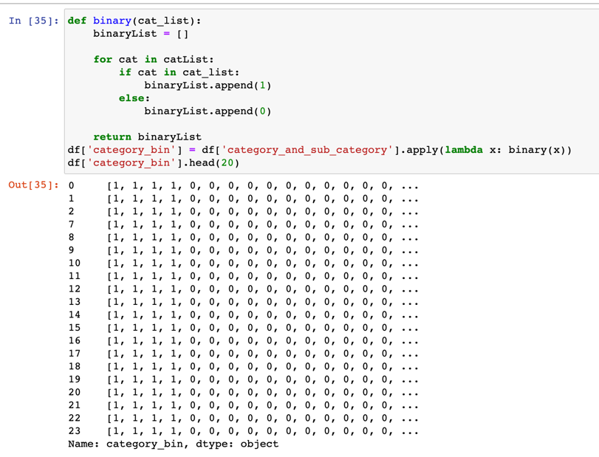

**Working with the Manufacturer Column**

Hornby appears to be the most popular Manufacturer followed by Q-Workshop.

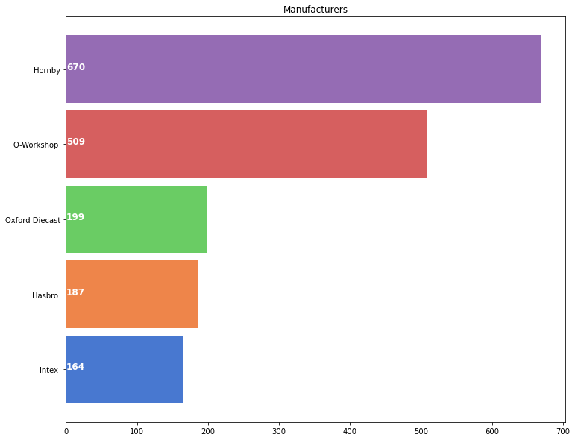

With the help of One-hot encoding, we have converted Manufacturer column as well to numerical as explained above.

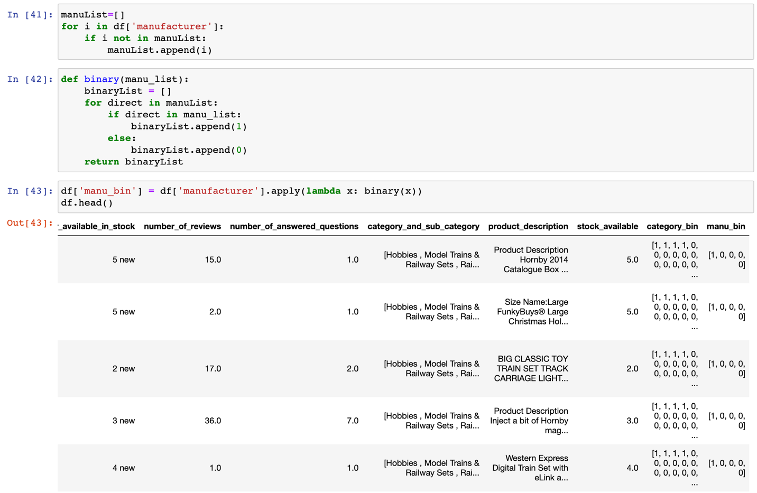

**Cosine Similarity**

**Cosine similarity** is a metric, helpful in determining, how similar the data objects are irrespective of their size. Mathematically, it measures the cosine of the angle between two vectors projected in a multi-dimensional space. If this distance is less, there will be a high degree of similarity, but when the distance is large, there will be a low degree of similarity.

Cosine similarity can be computed amongst arbitrary vectors. It is a *similarity measure* (which can be converted to a distance measure, and then be used in any distance-based classifier, such as nearest neighbor classification.)

**Cosine similarity is computed using the following formula:**

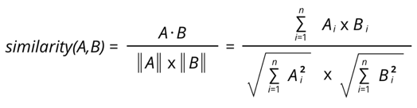

cosine similarity values range between -1 and 1, where -1 is perfectly dissimilar and 1 is perfectly similar.

The library contains both procedures and functions to calculate similarity between sets of data. The function is best used when calculating the similarity between small numbers of sets. The procedures parallelize the computation and are therefore more appropriate for computing similarities on bigger dataset.

Although cosine similarity fails the triangle inequality, it can be useful in KNN.

However, be wary that the cosine similarity is greatest when the angle is the same: cos(0º) = 1, cos(90º) = 0. Therefore, you may want to use sine or choose the neighbors with the greatest cosine similarity as the closest.

Although similarity measures are often expressed using a distance metric, it is in fact a more flexible measure as it is not required to be symmetric or fulfill the triangle inequality.

**We will we using Cosine Similarity for finding the similarity between 2 products.**

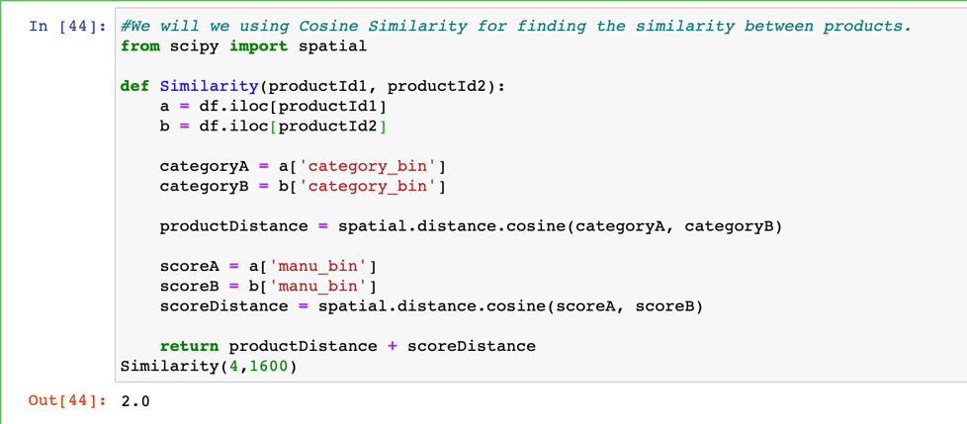

We see that the distance is about 2, which is high. The more the distance, the less similar the products are. Let's see what these products actually were.

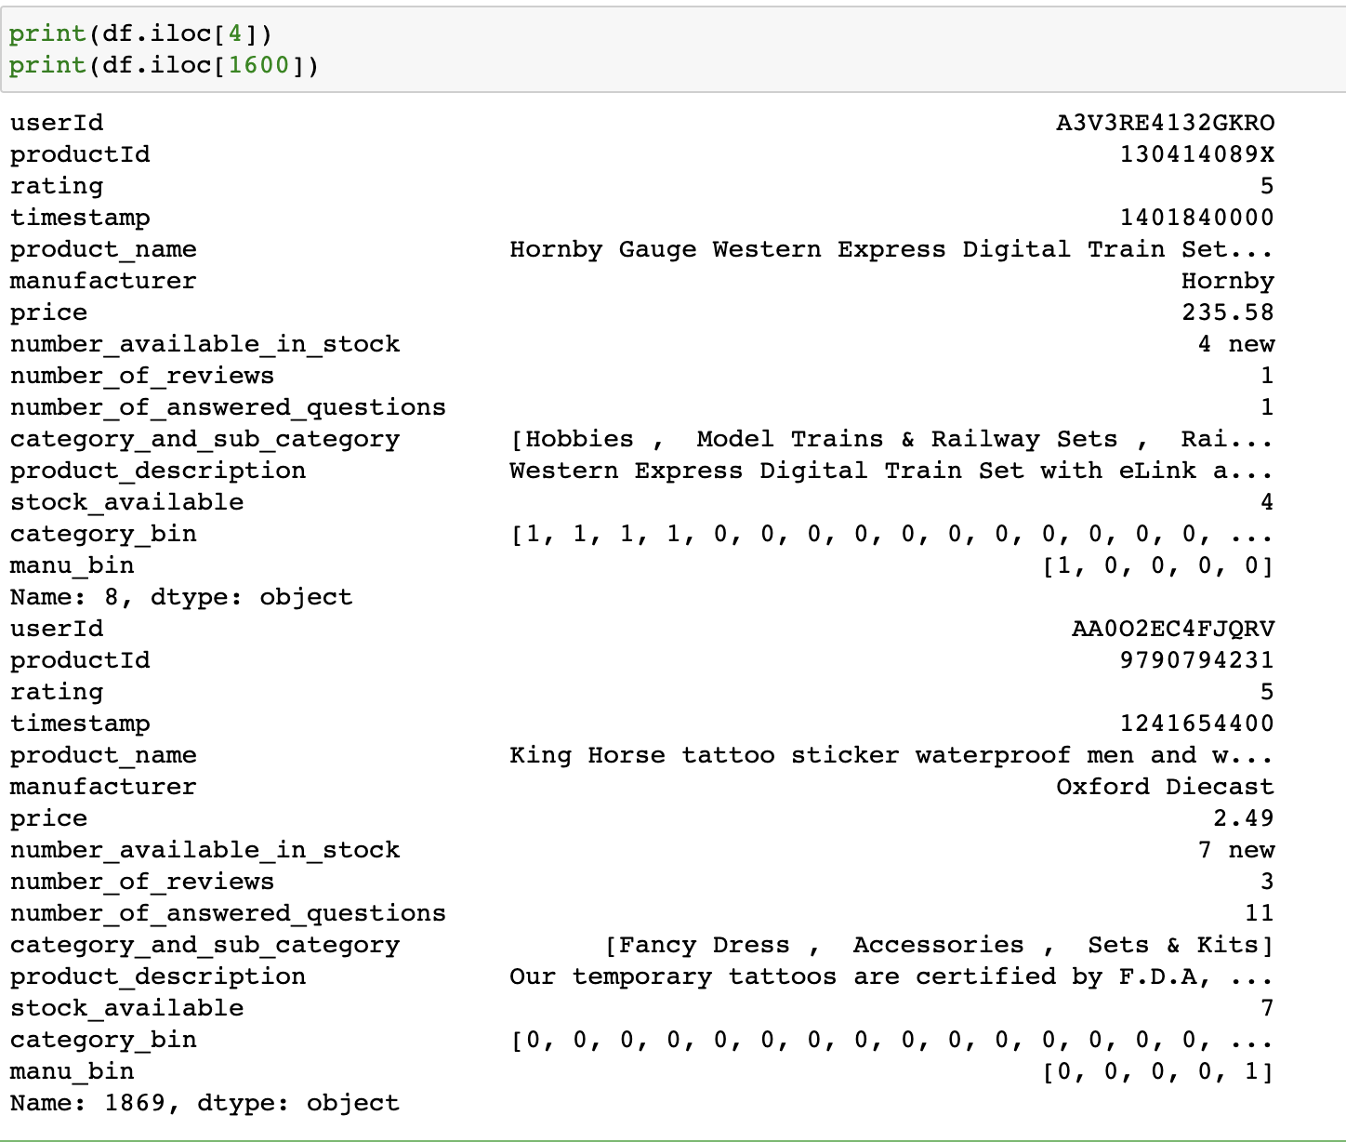

**It is evident that Hornby Gauge Western Express Digital Train Set and The Amazing Spiderman Stickers 2 are very different products with different category and manufacturer. Thus, the distance is huge.**

**K-Nearest neighbor:**

The principle behind nearest neighbor methods is to find a predefined number of training samples closest in distance to the new point and predict the label from these. The number of samples can be a user-defined constant (k-nearest neighbor learning) or vary based on the local density of points (radius-based neighbor learning). The distance can, in general, be any metric measure: standard Euclidean distance is the most common choice but in our system we are using Cosine metric as Euclidean distance has to satisfy symmetric and the triangle inequality.

Once we find the distance between the products, we can know which products are similar hence we built a recommendation System by implementing the supervised model K-Nearest Neighbors algorithm and

find the 10 nearest products that are similar. Predicting the rating of the given product based on its neighbors and compare it with the actual rating.

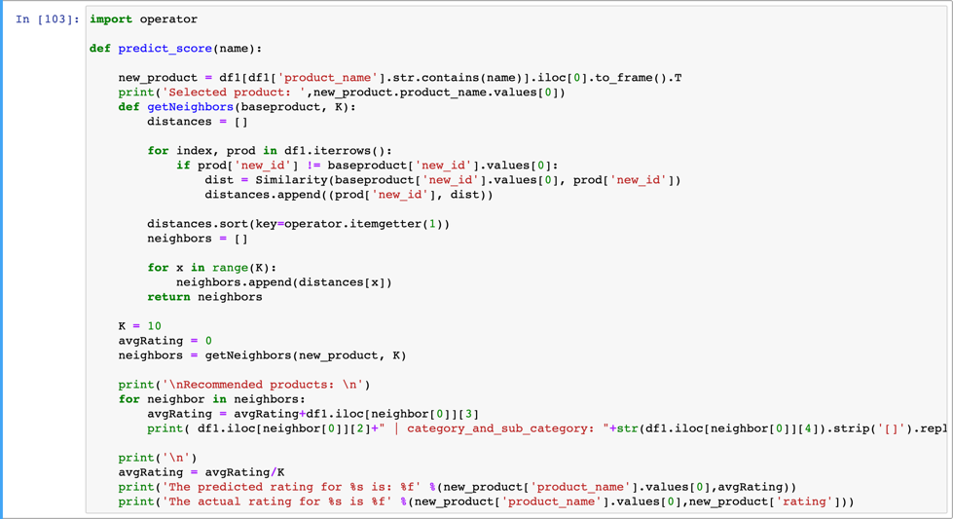

Finally, if the users search a product for example in the below image we have selected ‘Hornby 2014 Catalogue’ so our system would recommend 10 nearest products that are of same category or manufacturer as seen below.

We then predict the average rating of our product and compare it with our acting rating of our product. We are calculating average rating by adding all the ratings of the products that are closest to the product searched by user and then average it by K(Total number of neighbors). In our case avg rating is 4.6 which is not bad at all.

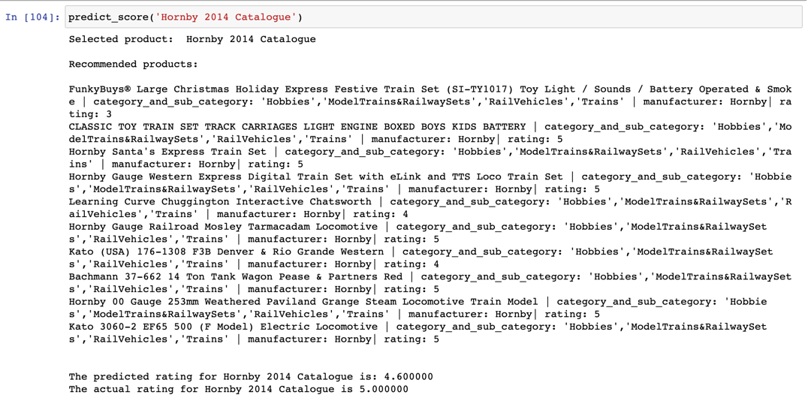

**RECOMMENDATION SYSTEM III**

Based on product rating we would find out the most popular product and recommend them to new customers. Popularity based are a great strategy to target the new customers with the most popular products sold on a business's website and is very useful to cold start a recommendation engine.

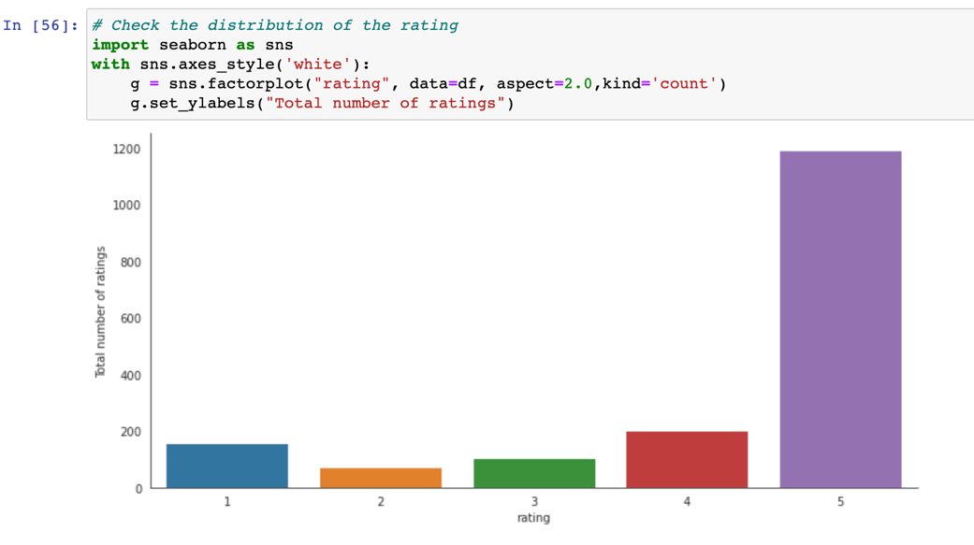

looks like a very high proportion of ratings received is either 5 or 4. Next highest count of ratings received is for 1 which is still a very high number (=100000).

Let’s compare the average rating for each product vs the number of people who rated for the product. This will help identify products which have a very high or low rating because of very few ratings received.

We have created a column name ‘Product_rating_counts’ which implies the maximum of users who rated for a particular product.

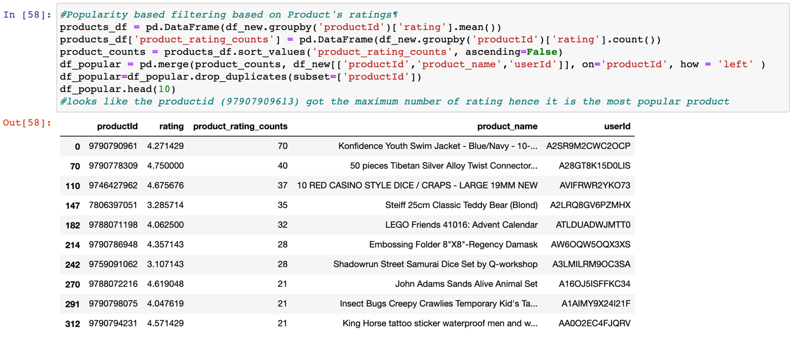

Looks like the productid (97907909613) got the maximum number of rating hence it is the most popular product.

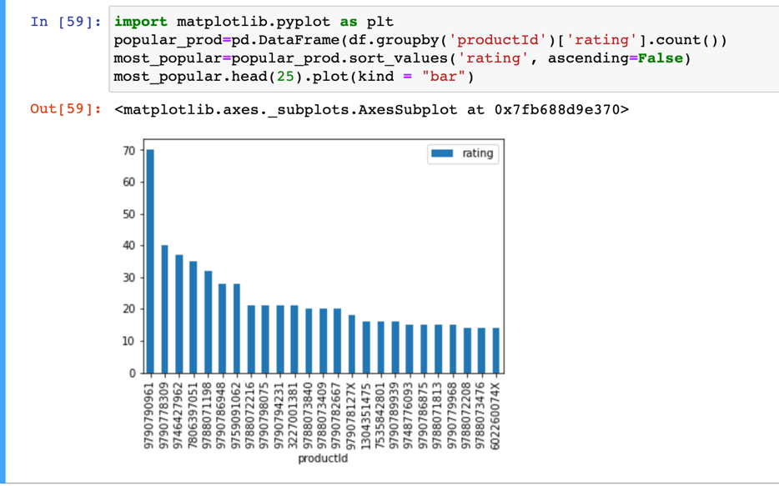

**User-Based Collaborative Filtering Using K-Nearest Neighbors (kNN)**

Once we have the user purchase history. We can recommend user preferred products, by comparing the user with other similar users based on the products purchase history and their rating for the product and then recommend them with K-Nearest Neighbors algorithm.

**User-Based Collaborative Filtering** is a technique used to predict the items that a user might like on the basis of ratings given to that item by the other users who have similar taste with that of the target user.

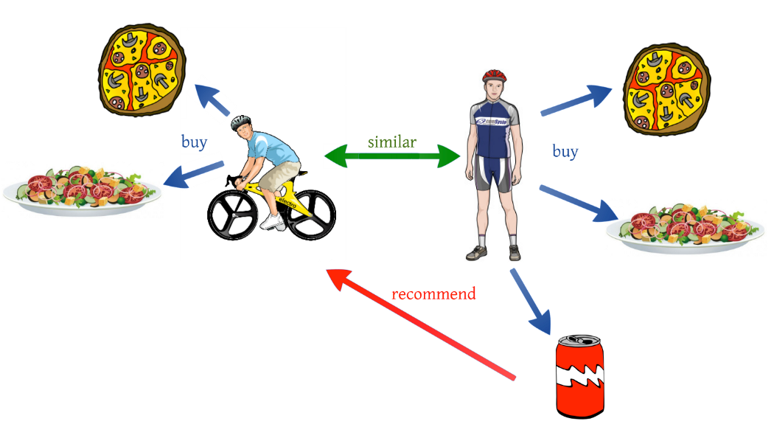

Collaborative ﬁltering models use the collaborative power of the ratings provided by multiple users to make recommendations. The main challenge in designing collaborative ﬁltering methods is that the underlying ratings matrices are sparse. Consider an example of an application in which users specify ratings indicating their like or dislike of speciﬁc product. Most users would have bought only a small fraction of the large universe of available products and as a result most of the ratings are unspeciﬁed.

The basic idea of collaborative ﬁltering methods is that these unspeciﬁed ratings can be imputed because the observed ratings are often highly correlated across various users and items. For example, consider two users named John and Molly, who have very similar tastes. If the ratings, which both have speciﬁed, are very similar, then their similarity can be identiﬁed by the ﬁltering algorithm. In such cases, it is very likely that the ratings in which only one of them has speciﬁed a value, are also likely to.

**User-based models:** Similar users have similar ratings on the same item. Therefore, if John and Molly have rated products in a similar way in the past, then one can use John’s observed ratings on the product Train to predict Molly’s rating on this product.

We first present ratings in a matrix, with the matrix having one row for each item (product_name) and one column for each user. The elements of this matrix are the ratings that are given to items by users. We convert our table to a 2D matrix and fill the missing values with zeros (since we will calculate distances between rating vectors). We then transform the values(ratings) of the matrix data frame into a scipy sparse matrix for more efficient calculations.

We are converting our 2D matrix into sparse using SVD for dimensionality reduction. It uses a matrix structure where each row represents a user, and each column represents an item. The SVD decreases the dimension of the utility matrix A by extracting its latent factors.

**SVD**

The factorization of this matrix is done by the singular value decomposition. It finds factors of matrices from the factorization of a high-level (user-item-rating) matrix. The singular value decomposition is a method of decomposing a matrix into three other matrices as given below: Where A is a m x n utility matrix, U is a m x r orthogonal left singular matrix, which represents the relationship between users and latent factors, S is a r x r diagonal matrix, which describes the strength of each latent factor and V is a r x n diagonal right singular matrix, which indicates the similarity between items and latent factors. The latent factors here are the characteristics of the items, for example, the genre of the music. The SVD decreases the dimension of the utility matrix A by extracting its latent factors. It maps each user and each item into a r-dimensional latent space. This mapping facilitates a clear representation of relationship.

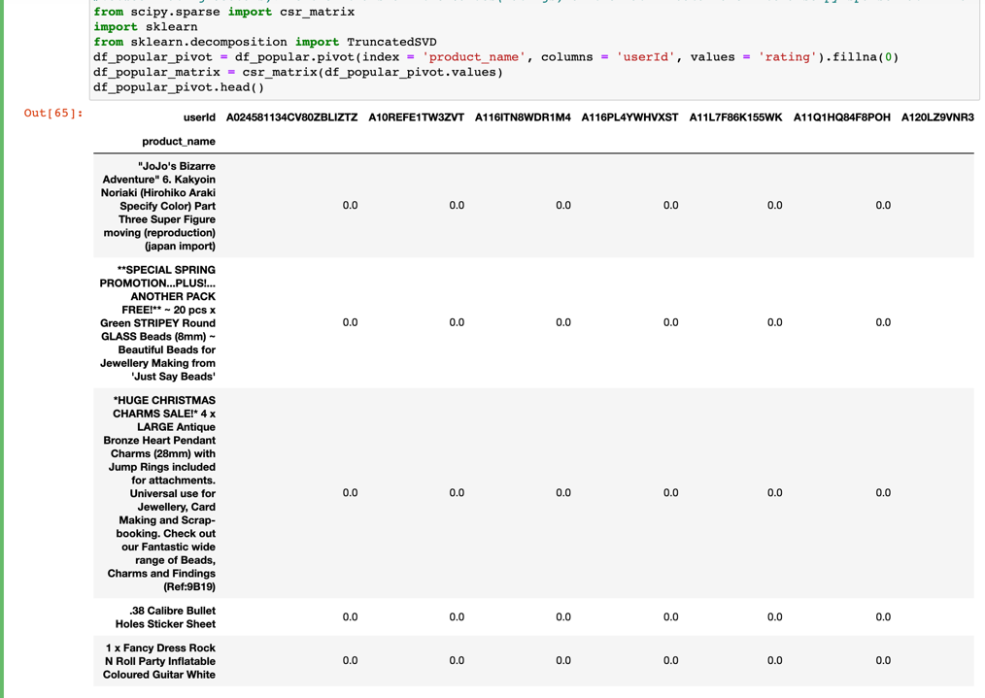

**Implement KNN**

kNN is a machine learning algorithm to find similar users based on common product ratings, and make predictions using the average rating of top-k nearest neighbors. kNN algorithm measures distance to determine the “closeness” of instances. It then classifies an instance by finding its nearest neighbors and picks the most popular class among the neighbors. The principle behind nearest neighbor methods is to find a predefined number of training samples closest in distance to the new point and predict the label from these.

We use sklearn.neighbors algorithm. The algorithm we use to compute the nearest neighbors is “brute”, and we specify “metric=cosine” so that the algorithm will calculate the cosine similarity between rating vectors. Finally, we fit the model. We then find the k item that have the most similar user engagement vectors.

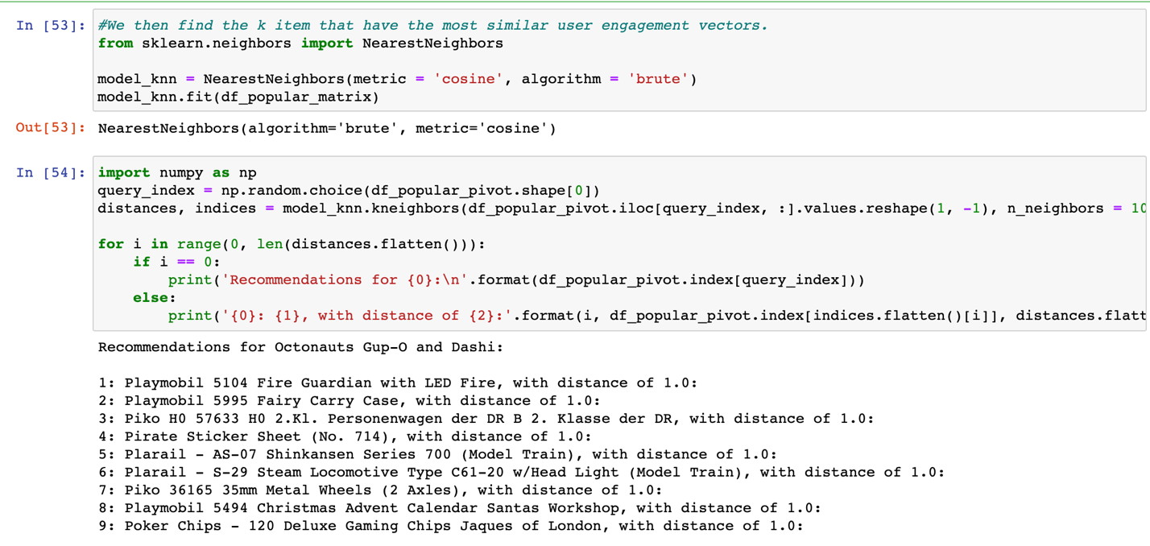

For instance, if the user buys ‘Octonauts Gup-O and Dashi’ as in the above image, in order to recommend products to the user, we will compare similar users by using distance metric ‘Cosine’ and find nearest k users by using KNN.

From the above example, we can see that all the products we have recommended to that particular user are at a distance of 1 which is not far so we have recommended products with that distance range.

**RECOMMENDATION SYSTEM IV**

Model based approaches, which involve a step to reduce or compress the large but sparse user-item matrix.

Model-based collaborative filtering system Recommend items to users based on purchase history and similarity of ratings provided by other users who bought items to that of a particular customer.

A model based collaborative filtering technique is chosen here as it helps in making predicting products for a particular user by identifying patterns based on preferences from multiple user data.

Utility Matrix based on products sold and user reviews Utility Matrix

An utility matrix is consists of all possible user-item preferences (ratings) details represented as a matrix. The utility matrix is sparce as none of the users would buy all the items in the list, hence, most of the values are unknown.

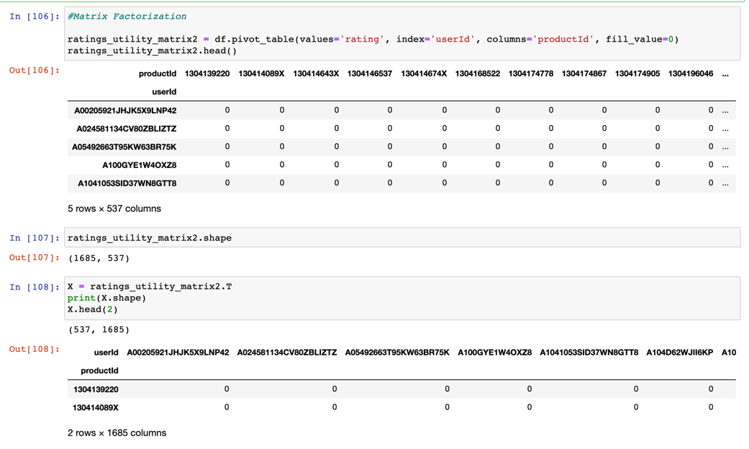

If the matrix is mostly empty, reducing dimensions can improve the performance of the algorithm in terms of both space and time. You can use various methods like matrix factorization or autoencoders to do this. Many techniques such as SVD.

One of the popular algorithms to factorize a matrix is the singular value decomposition (SVD) algorithm. SVD came into the limelight when matrix factorization was seen performing well in the Netflix prize competition. Other algorithms include PCA and its variations, NMF, and so on.

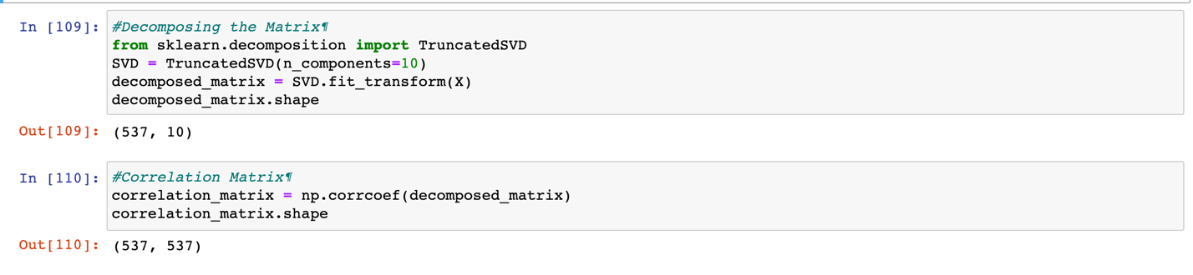

# **Making recommendation - Example ProductId- 9788073409**

Isolating Product ID # 9788073409 from the Correlation Matrix. Assuming the customer buys Product ID # 9788073409 (randomly chosen).

**Output:** We are finding similarity using correlation if the two products have a correlation of 1 then they are highly related to each other hence we are taking the products that have the correlation between 1 and 0.9 and recommending them. To test our code, we have taken an example of one product and shown below. As you can see in the below image, we have takenthe ProductID (9788073409) and compared it with other similar products and recommend them.

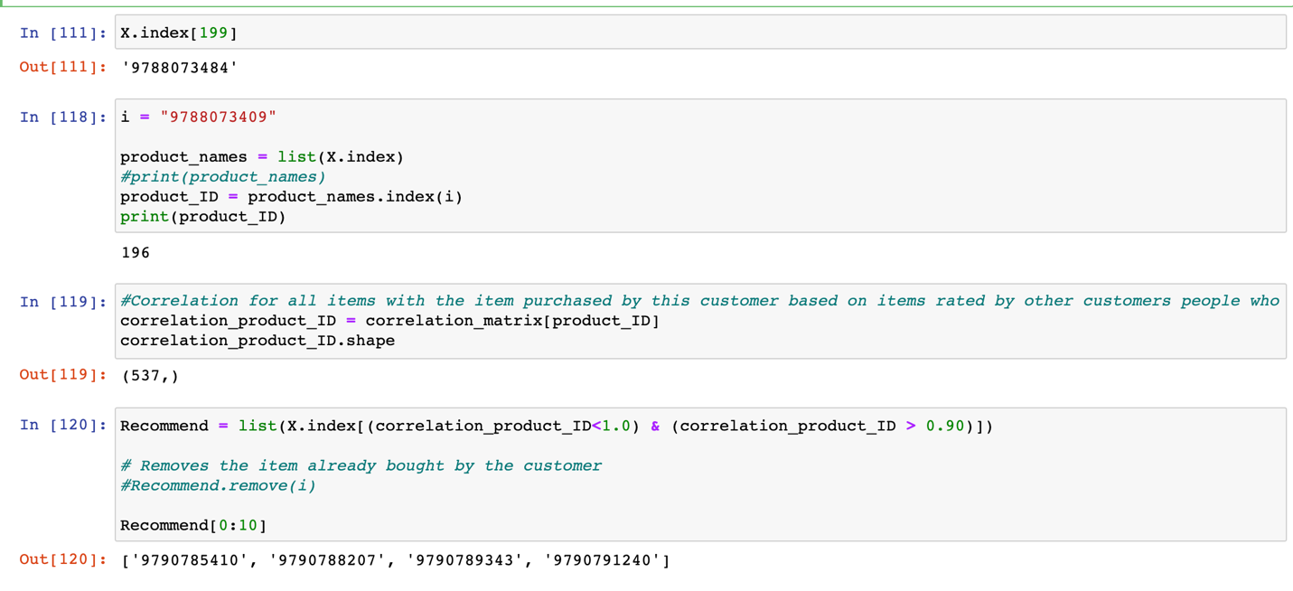

**CONCLUSION**

* Based on business requirement, users, purchase history and ratings, we have recommended a total of 4 recommend systems which can increase the sales of a company and also enhance the user experience and save the user time.
* We have used both Supervised and Unsupervised learning techniques in our study.
* In Unsupervised learning we have used K-Means Clustering techniques. Found out clusters based on similar words and predicting the products based on the clusters found and recommending them.
* In Supervised learning with the help of Cosine metric we found the distance between the products and fit KNN algorithm to recommend products.
* There are no of advantages for recommended system as 35% of most ecommerce business revenue gets generated from recommended system.
* We have used collaborative and model-based filtering techniques which are used in real time by Netflix and other major ecommerce websites like Amazon to recommend products and movies to the user.

**CHALLENGES AND DIFFICULTIES**

* As the topic is to recommend products to the users, initially we tried to figure it whether it's supervised or unsupervised, but we have built recommendation engine using both supervised and unsupervised learning as our model can be done using both ways.
* We have implemented new distance metric ‘Cosine similarity’ instead of Euclidian distance or other common distance measure used. As the topic is new, we tried to understand the cosine similarity and why it's used instead of other distance measures and implemented the same in our project as explained in our study.
* We tried to understand the user based and model-based technique and implemented the same in our project. As the topic is new for us, we tried to understand the topic, algorithms and distance metrics that can be used and also, we tried to understand the no if ways we can use it by trying different technique.

**FUTURE ADVANCEMENT**

As we have done recommendation engines and implemented same using product details and displayed using web. We can do the same using product images and display using User Interface. To implement that needs a lot of knowledge on deep learning, Artificial Neural Network and Convolutional Neural Network. Due to time constraint, we couldn't implement it. We are very interested to study more and do further research on the topic in the future and implement deep learning application.

**REFERENCES:**

* <https://www.barilliance.com/use-product-recommendations/>
* <https://towardsdatascience.com/unsupervised-classification-project-building-a-movie-recommender-with-clustering-analysis-and-4bab0738efe6>
* <https://www.analyticsvidhya.com/blog/2018/06/comprehensive-guide-recommendation-engine-python/>
* <https://medium.com/@ashutoshsingh93/recommendation-system-for-e-commerce-using-collaborative-filtering-fa04d6ab1fd8>
* <https://www.kaggle.com/>
* <https://data.world/>
* We have taken amazon data set sample for our study.